Making your HTML Location-Aware

Do you know where you are right now? You don’t? Well, do you want to know where you are? You do??! Okay!! Then you’re reading the right chapter!!! Continue on and you will always know where you are!!!!!!!!!!

Contents

1. Does your browser support Geolocation? 1

2. Retrieving your current position 1

3. Options Array Parameter 1

4. Position object properties 2

5. Error Codes 3

6. Seeing it all in action 3

# Does your browser support Geolocation?

The first step to knowing where you are is to know whether you can actually find out. How can you determine that? Well, you need to know if your browser supports geolocation! Use the following javascript code to determine if the navigator.geolocation object exists when you load an HTML page in your browser.

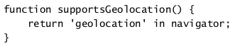

# Retrieving your current position

Okay, so your browser supports geolocation? It does! Good!! Now you can see where you are located on this great earth we live on!!!

You can retrieve your position using the getCurrentPosition or watchPosition methods in navigator.geolocation.

* getCurrentPosition is a one-time call to get the current position as a Position object.



* watchPosition will determine if your position changes and notify you of the change until you tell it to stop.

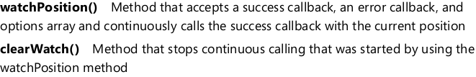

# Options Array Parameter

The watchPosition and getCurrentPosition methods accept an options array as a parameter! This is exciting!!! We can pass in options for our geo location calls!!! Yep, it sure is!!! And here are the parameters that we can add to your options array:

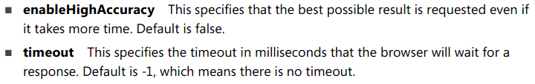

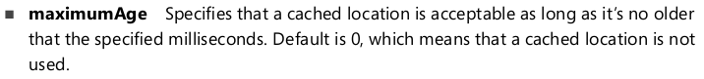

# Position object properties

getCurrentPosition and watchPosition methods return a position object! The position object contains the following properties:



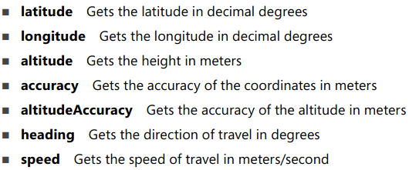

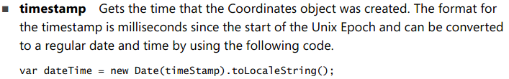

# Error Codes

I know I know.. errors are lame.. especially when they aren’t descriptive.. Well you can make your descriptive so we at least know whats going on!! Check below!

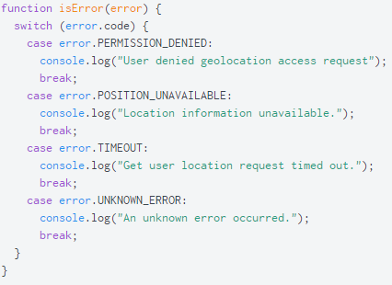

# Seeing it all in action

I bet your itching to see how this works in code! Well, you’re in luck!!! Head over to this link and have fun!!!!!!

Example for getCurrentPosition: <https://jsfiddle.net/puLutovd/3/>

Example for watchPosition: <https://jsfiddle.net/tt0ug3rs/2/>